1. **Find the angles of reflection for 1 and 2.**

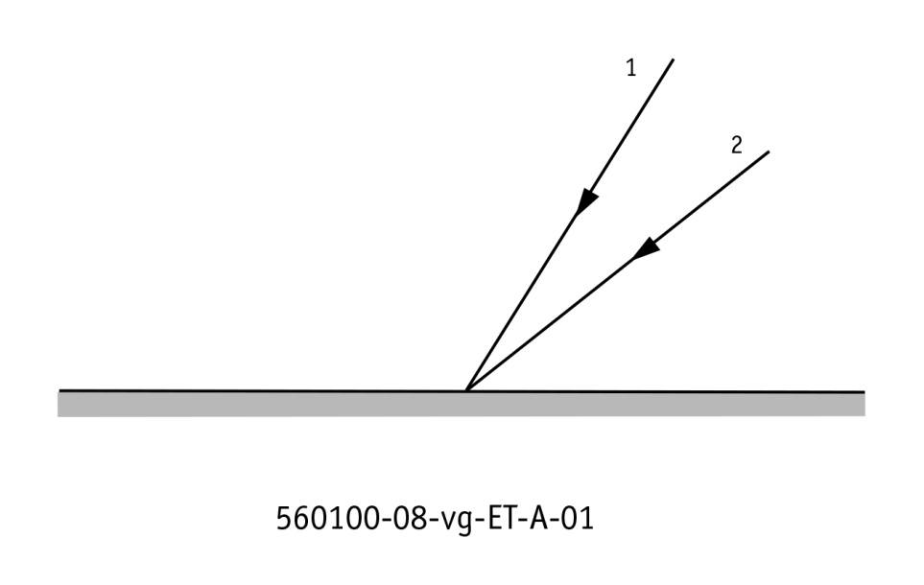

* figure 1

1. **What is the angle of reflection on the last mirror?**

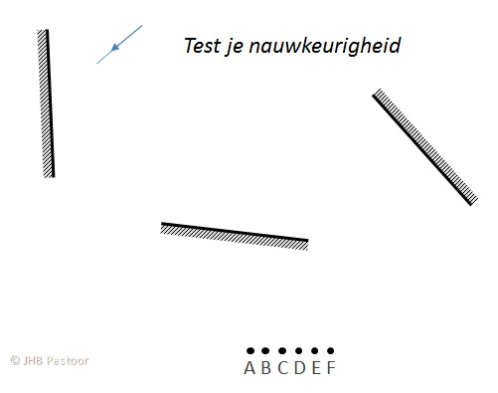

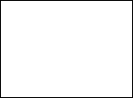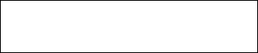

* figure 2

1. 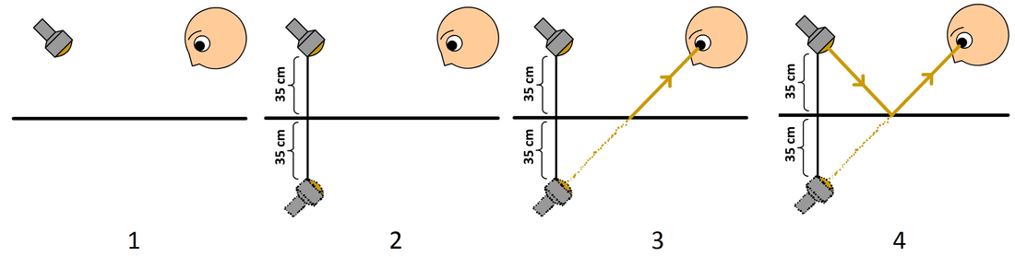D**oes the lamp shine in the boy’s face?**

* Figure 3